Early Diabetes Prediction In Children

Don't find customers for your product but find products for your customers

1. Team

Team Name: DIATECH
Team Logo :

Team Members:
- Sneha. S, Researcher, 9550699080
- Deekshitha. B, Developer, 6300221699
- Anushka, Analyst,9100765113
- Taniswi, Presenter, 9652994569

2. Problem/Opportunity Domain

Domain of Interest: Healthcare

The innovative idea focuses on the pediatric healthcare sector, particularly the early detection and management of diabetes in children aged 0–13 years using advanced machine learning techniques. This domain is critical because diabetes in children can lead to severe health complications if not identified and treated early. By leveraging data-driven insights, this innovation aims to enhance diagnosis accuracy, optimize prevention strategies, and improve health outcomes for children.

Description of the Domain: The healthcare domain involves delivering effective diagnosis, treatment, and preventive care to improve patient outcomes. In pediatric healthcare, challenges include limited symptom articulation by children, lack of tailored diagnostic tools, and early disease detection difficulties. Opportunities lie in leveraging machine learning for personalized care, predictive diagnostics, and improving accessibility to innovative, child-centric solutions.

Why did you choose this domain?: I chose the healthcare domain, specifically pediatric care, due to a personal passion for using technology to improve lives and address the critical gap in early detection of diseases in children. This domain offers immense potential for impactful innovation, as machine learning can revolutionize diagnostics and provide timely, life-saving interventions for young patients.

3. Problem/Opportunity Statement

Problem Statement: The lack of efficient, accessible, and accurate diagnostic tools for early-stage diabetes in children aged 0 to 13 leads to delayed diagnosis and treatment, increasing the risk of severe complications. This problem highlights the need for a solution that can provide timely predictions and insights, enabling healthcare professionals and parents to take prompt and informed action.

Problem Description: Early-stage diabetes in children often goes undiagnosed due to subtle symptoms and limited access to specialized healthcare tools. This delay can lead to severe health complications, affecting the child’s growth and quality of life. The challenge lies in developing a reliable, easy-to-use predictive model to aid early diagnosis and intervention, ensuring better health outcomes.

Context (When does the problem occur): The problem arises when children exhibit mild or ambiguous symptoms of diabetes, such as increased thirst or fatigue, which are often mistaken for common childhood conditions. It is especially prevalent in regions with limited access to pediatric endocrinologists or advanced diagnostic facilities, delaying early detection and treatment.

Alternatives (What does the customer do to fix the problem): Currently, customers rely on periodic visits to general physicians or pediatricians, where symptoms may be assessed without specific diabetes screening. In some cases, they may resort to over-the-counter remedies for symptom management or use outdated home glucose testing kits. Others seek advanced diagnostic tests, which are often costly and inaccessible in rural or underserved areas. These alternatives are either insufficient or impractical for early detection and continuous monitoring in children.

Customers (Who has the problem most often): The primary customers are parents of children aged 0 to 13, especially those with a family history of diabetes or early symptoms. Pediatricians and healthcare providers are also affected, as early diagnosis is challenging. Healthcare clinics, particularly in rural or underserved areas, face difficulties due to the lack of efficient screening tools for early diabetes detection in children.

Emotional Impact (How does the customer feel): Customers often feel anxious and helpless due to their child’s health uncertainty. Parents are frustrated by the lack of early detection tools, which leads to delayed diagnoses and potential complications. Healthcare providers may feel overwhelmed by the difficulty in accurately diagnosing diabetes in children at an early stage, contributing to stress and a sense of inadequacy.

Quantifiable Impact (What is the measurable impact): The lack of early detection for childhood diabetes results in higher healthcare costs due to late diagnoses and extended treatments. Families face increased medical bills and hospital stays. Delayed care also leads to long-term health complications, affecting the child’s quality of life and productivity. The overall financial burden on families and healthcare systems is significant.

Alternative Shortcomings (What are the disadvantages of the alternatives):
Current solutions like manual screenings and traditional diagnostic tests are time-consuming, costly, and often miss early symptoms of diseases. They are also resource-intensive and not scalable, especially in underserved areas. Moreover, they rely on subjective assessments, which can lead to delays in detection and treatment. These limitations result in inefficiency and a higher likelihood of undiagnosed conditions.

4. Addressing SDGs

Relevant Sustainable Development Goals (SDGs):
- SDG 3: Good Health and Well-Being – AI-driven early detection improves health outcomes and access to quality healthcare.
- SDG 9: Industry, Innovation, and Infrastructure – Promotes technological innovations in healthcare, strengthening health infrastructure.
- SDG 10: Reduced Inequality – Helps bridge healthcare gaps, providing affordable diagnostic services in underserved areas.

How does your problem/opportunity address these SDGs?:
- SDG 3: Good Health and Well-Being – By enabling early detection and accurate diagnosis of diabetes, we can improve health outcomes, reduce complications, and enhance access to timely medical interventions for those at risk.
- DG 9: Industry, Innovation, and Infrastructure – Leveraging AI-driven solutions promotes innovation within the healthcare sector, enhances infrastructure for medical diagnostics, and encourages the development of advanced technologies for more efficient healthcare systems.
- SDG 10: Reduced Inequality – AI models can be deployed in resource-constrained areas to provide accessible, low-cost diagnostic solutions, helping bridge the healthcare gap between urban and rural populations and improving health equity.
- SDG 17: Partnerships for the Goals – Solving this problem involves collaboration between healthcare providers, AI developers, and governments, fostering partnerships that drive the development of sustainable, data-driven healthcare solutions.

5. Stakeholders
- Who are the key stakeholders involved in or affected by this project?
The key stakeholders in the "Early Diabetes Prediction in Children" project include children (aged 0–13) and their parents/guardians, who are the primary beneficiaries. Healthcare professionals like pediatricians, endocrinologists, nurses, and dietitians play vital roles in diagnosis and management. Researchers, data scientists, and AI developers ensure accurate and reliable machine learning models, while software engineers create user-friendly tools. Hospitals, clinics, and diagnostic labs support implementation, with regulators and government bodies ensuring compliance with health standards and policies. NGOs and advocacy groups raise awareness, while schools and insurance providers contribute to prevention strategies and coverage. Each stakeholder is crucial to enhancing diagnosis accuracy and improving health outcomes.

- What roles do the stakeholders play in the success of the innovation?
Stakeholders play critical roles in the success of this innovation. Children and parents provide data and adhere to prevention or treatment plans, while healthcare professionals diagnose, interpret results, and manage care. Researchers and AI developers design and refine machine learning models, and software engineers ensure usability of tools. Hospitals and labs facilitate implementation, while regulators and governments ensure compliance and support funding. NGOs and advocacy groups promote awareness, schools assist in early detection, and insurers provide coverage for diagnostics and care. Collaboration among these stakeholders ensures effective early diabetes prediction and better health outcomes.

- What are the main interests and concerns of each stakeholder?
The main interests of children and parents are early detection, effective prevention, and access to treatment, with concerns about accuracy, privacy, and cost. Healthcare professionals are interested in reliable tools to enhance diagnosis and care but may worry about the technology's complexity or integration into workflows. Researchers and AI developers focus on creating accurate, unbiased models, while addressing data quality and ethical concerns. Hospitals and labs aim for efficient implementation, balancing costs and operational demands. Regulators prioritize compliance, data privacy, and patient safety, while NGOs and schools emphasize awareness and education. Insurers are interested in cost-effective solutions but may be cautious about coverage risks.

- How much influence does each stakeholder have on the outcome of the project?
Stakeholders have varying levels of influence on the project’s outcome. Healthcare professionals, researchers, and AI developers hold significant influence through their expertise in diagnosis, data modeling, and system design. Parents and children are critical as they provide data and adhere to prevention or treatment plans. Hospitals and labs impact the project through infrastructure and implementation capabilities, while regulators ensure compliance and trust in the system. NGOs and schools have moderate influence by driving awareness and adoption, while insurers and government bodies can shape funding and accessibility. Collaboration across these stakeholders determines the project’s success.
- What is the level of engagement or support expected from each stakeholder?
The level of engagement varies among stakeholders. High engagement is expected from parents, healthcare professionals, researchers, and AI developers, as they are central to data collection, diagnosis, and model development. Hospitals, labs, and software engineers need strong support to implement and operate the system effectively. Regulators, government bodies, and insurers are expected to provide oversight, funding, and policy support. Moderate engagement from NGOs and schools is crucial for awareness and early screening efforts. Each stakeholder’s active participation ensures the innovation’s adoption and effectiveness.
- Are there any conflicts of interest between stakeholders? If so, how can they be addressed?
Conflicts of interest may arise, such as parents’ concerns over data privacy versus researchers’ need for comprehensive data, or healthcare professionals’ reliance on traditional methods versus new AI tools. Insurers might resist covering predictive tests due to cost concerns. These conflicts can be addressed through transparent communication, strict data privacy protocols, stakeholder education on AI benefits, and policies that balance affordability with innovation. Collaboration and trust-building are key to resolving these issues.
- How will you communicate and collaborate with stakeholders throughout the project?
Communication and collaboration will involve regular meetings, progress reports, and user-friendly platforms for updates. Workshops and training sessions will engage healthcare professionals, parents, and educators. Feedback channels, like surveys or focus groups, will ensure stakeholder input. Transparent communication will foster trust and alignment on project goals.
- What potential risks do stakeholders bring to the project, and how can these be mitigated?
Stakeholders may bring risks such as resistance to change from healthcare professionals, data privacy concerns from parents, and model bias or errors from researchers. These can be mitigated through stakeholder education, robust data security measures, and rigorous testing of AI models. Transparent policies and addressing concerns early will build trust and reduce resistance.

6. Power Interest Matrix of Stakeholders

Power Interest Matrix:
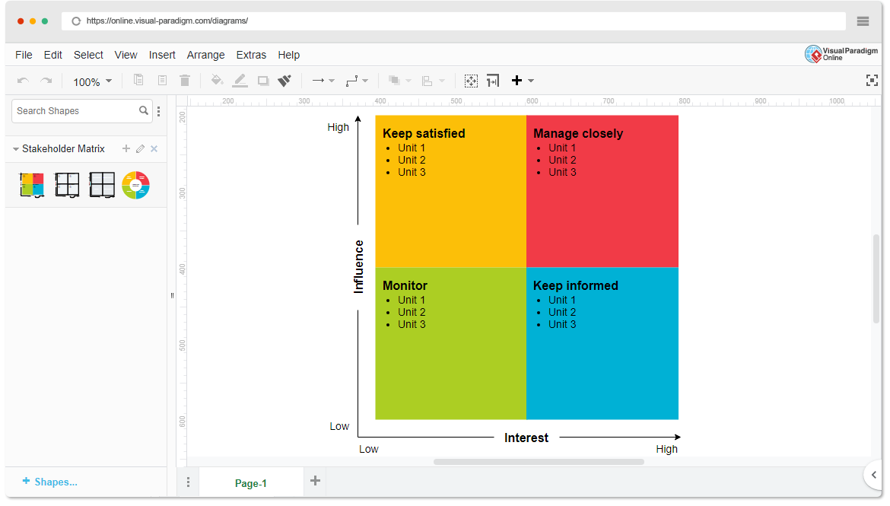
- High Power, High Interest: Healthcare Providers (e.g., Pediatricians, Endocrinologists), Medical Researchers, Policy Makers (e.g., Health Departments, Government bodies)
- High Power, Low Interest: Health Insurance Providers, Pharmaceutical Companies, Investors
- Low Power, High Interest: Parents and Caregivers of children, Teachers, School Nurses, Community Health Workers
- Low Power, Low Interest: Technology Providers (e.g., software vendors), General Public, Non-Health-related NGOs

7.Empathetic Interviews

I need to know  (thoughts, feelings, actions) | Questions I will ask  (open questions) | Insights I hope to gain
Thoughts | What are your thoughts on prediabetes prediction?
 | How do you feel about the current [process, service, or technology]? | Understand patients' views, beliefs, and opinions about the subject matter.
 | What challenges do you think people face in [specific context]? | Identify knowledge gaps or misconceptions that might affect behaviors or decisions.
Feelings | How do you feel when using [a product or service]? | Gauge emotional responses to certain situations, which can help improve user experiences.
 | Why do you feel [a particular emotion] about [a situation]?
 | Can you describe a time when you felt frustrated or happy with [a specific experience]? | Recognize pain points, desires, or motivations behind decisions.
actions | What’s the first thing you do when you need to [solve a problem or achieve a goal]? | What participants do or how they behave based on their thoughts and feelings.
 | What steps do you usually take when faced with? | Understand how participants take action based on their thoughts and feelings.
 | How do you decide to [take action or make a choice] in situations like diabetes? | Discover patterns of behaviour that can inform improvements in services, products, or processes.

SKILLED INTERVIEW REPORT

User/Interviewee | Questions Asked | Insights gained (NOT THEIR ANSWERS)
Abhishek Verma,  Student | How do you feel about your child’s health and diabetes prevention? | Parents are proactive but often lack clarity on the early signs of diabetes.
Srinivasan P., Parent | What are your thoughts on AI tools for early diabetes detection in children? | Healthcare professionals are interested in AI tools but are concerned about their accuracy and integration into current systems.

Key Insights Gained:
- Insight 1:
Parents are actively concerned about their child’s health but lack clear guidance on early signs of diabetes. They want simple, reliable tools to monitor and assess risk, but face difficulty in understanding when to take action.
- Insight 2:
Healthcare professionals are open to using AI tools for early diabetes detection but are cautious about their accuracy and seamless integration into existing clinical practices. They value solutions that are easy to use and provide actionable insights for timely interventions.

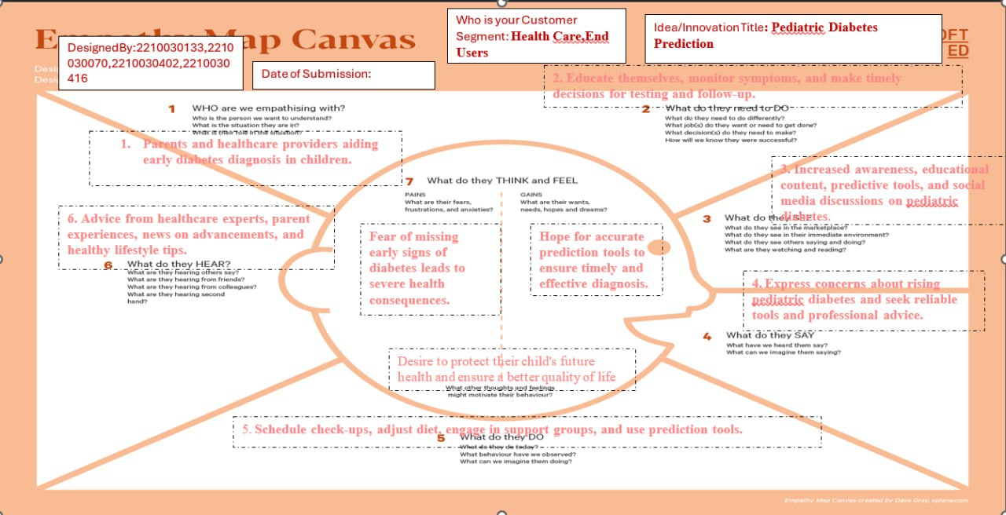Empathy Map

8.Empathy Map

- Who is your Customer?

• Parents:
- Age: 25-45 years
- Profession: Caregivers, working parents, or stay-at-home parents
- Interests: Child’s health, preventative care, early detection of health issues like diabetes
- Goals: Ensure early detection, reduce complications, provide timely medical intervention
- Needs: Easy access to reliable health data, reassurance, preventive guidance

• Healthcare Professionals:
- Age: Adults with medical training (mid-career professionals)
- Profession: Pediatricians, endocrinologists, nurses, dietitians
- Goals: Enhance diagnosis and treatment, reduce diabetes-related complications
- Needs: Accurate machine learning models for diagnosing diabetes risk, integration into clinical practice

- Who are we empathizing with?

• Parents:
- Concerns: Seeking early detection of diabetes to protect their child's health
- Challenges: Difficulty in understanding symptoms and managing care

• Healthcare Professionals:
- Concerns: Aiming to improve diagnosis and treatment of pediatric diabetes
- Challenges: Struggles with accurate early detection and time constraints

- What do they need to DO?
• Parents:
- Tasks: Input health data, monitor risk factors, follow advice
- Decisions: Decide when to seek professional help based on predictions
- Success: Early detection, effective prevention, improved outcomes

• Healthcare Professionals:
- Tasks: Use predictive tools for diagnosis, recommend treatments, monitor progress
- Decisions: Determine the best course of action based on predictions
- Success: Accurate diagnosis, timely intervention, positive outcomes

- What do they SEE?

• Parents:
- Physical Environment: Medical records, health apps, doctor’s advice
- Digital Environment: Predictive health tools, notifications, health tracking apps
- Trends: Growing awareness of childhood diabetes and prevention
- Influence: Clear, user-friendly tools motivate early detection

• Healthcare Professionals:
- Physical Environment: Clinical settings, medical charts, patient histories
- Digital Environment: EHR systems, predictive analytics dashboards
- Trends: Increasing adoption of AI in healthcare
- Influence: Accurate, intuitive diagnostic tools encourage better decision-making

- What do they SAY?
• Parents:
- Comments: "I want to make sure my child stays healthy."
- Goals: "I need a simple way to track my child’s health and catch problems early."
- Frustrations: "It’s hard to know when to be concerned about my child’s health."
• Healthcare Professionals:
- Comments: "I wish there was an easier way to spot early diabetes in kids."
- Goals: "I need reliable tools to diagnose and treat pediatric diabetes."
- Frustrations: "Current tools are time-consuming and not always accurate."

- What do they DO?
• Parents:
- Actions: Input health data, monitor health (weight, diet, symptoms), visit professionals
- Habits: Regular check-ups, track child’s health online, monitor family history
- Actions to Solve Problems: Seek second opinions, research early signs of diabetes
• Healthcare Professionals:
- Actions: Review patient data, use diagnostic tools, recommend treatments
- Habits: Routine exams, using EHR for updates
- Actions to Solve Problems: Use diagnostic tools or AI systems, consult specialists for complex cases
- What do they HEAR?
• Parents:
- From peers: Conversations about health concerns, preventive care for children
- From media: Health news, parenting advice, diabetes prevention tips
- Influencers: Family doctors, online health forums, wellness advocates
• Healthcare Professionals:
- From peers: Discussions on new diagnostic tools, AI in healthcare
- From industry: Medical journals, pediatric diabetes conferences
- Influencers: Research studies, industry leaders, healthcare organizations
  - .

- What do they THINK and FEEL?
• Parents:
- Fears: Fear of missing early signs of diabetes, long-term impact on child’s health
- Motivations: Desire for early detection, prevention, reassurance
- Alignment with Actions: Driven by fear and desire for prevention
• Healthcare Professionals:
- Fears: Concerned about misdiagnosis or missing early indicators due to limited tools
- Motivations: Desire for accuracy, effective care, and better outcomes
- Alignment with Actions: Motivated by the need for reliable, accurate tools
- Pains and Gains
- Pains:
  - Parents: Lack of clear warning signs, difficulty accessing reliable insights, anxiety about managing health risks
  - Healthcare Professionals: Limited time and tools for early detection, risk of misdiagnosis, challenges integrating new tech
- Gains:
  - Parents: Reliable tool for early detection, peace of mind, improved outcomes
  - Healthcare Professionals: Accurate diagnostic support, seamless integration, better patient outcomes
- Benefits: Confidence in early detection, actionable insights, and improved management of diabetes risk

9. Persona of Stakeholders

Stakeholder:
- Demographics:
  - Age: 25-45 years
  - Gender: Primarily mothers (but includes fathers)
  - Income: Middle to upper-middle class
  - Location: Urban and semi-urban areas with access to healthcare

Goals:
- Parents (of children aged 0–13):
  - Detect diabetes early to prevent complications
  - Access simple, reliable tools to monitor and assess risk
  - Take proactive steps to safeguard their child’s health
- Healthcare Professionals (Pediatricians, Endocrinologists):
  - Accurately diagnose early-stage diabetes in children
  - Use efficient, data-driven tools to improve care
  - Provide better health outcomes with minimal extra workload

Challenges:
- Parents:
  - Difficulty identifying early diabetes symptoms
  - Lack of reliable, easy-to-use tools for risk assessment
  - Anxiety about when to seek medical help
- Healthcare Professionals:
  - Lack of accurate tools for early detection of diabetes
  - Time constraints and heavy workload
  - Risk of misdiagnosis or delayed treatment due to poor data

Aspirations:
- Parents:
  - Ensure their child grows up healthy and free from diabetes complications
  - Feel confident managing their child’s health with effective tools
- Healthcare Professionals:
  - Improve early detection and treatment of diabetes in children
  - Use innovative solutions for better, more efficient care

Needs:
- Parents:
  - A simple, accessible tool for monitoring diabetes risks
  - Clear guidance on managing and preventing diabetes
- Healthcare Professionals:
  - Accurate diagnostic tools for early diabetes detection
  - Seamless integration of tools into their existing workflows

Pain Points:
- Parents:
  - Unaware of early diabetes symptoms
  - Lack of reliable, easy-to-use tools
  - Anxiety about their child’s health
- Healthcare Professionals:
  - Inaccurate diagnostic tools
  - Time and workload challenges
  - Risk of misdiagnosis or delayed treatment

Story:
A worried parent notices unusual symptoms in their child but doesn’t know if it’s serious. They lack reliable tools to assess risk and feel anxious. At the same time, a pediatrician struggles to detect diabetes early due to limited tools.
With the innovation, the parent uses an app to track symptoms and get alerts. They visit the pediatrician, who uses accurate AI tools to confirm the diagnosis. Together, they ensure timely care and safeguard the child’s health.

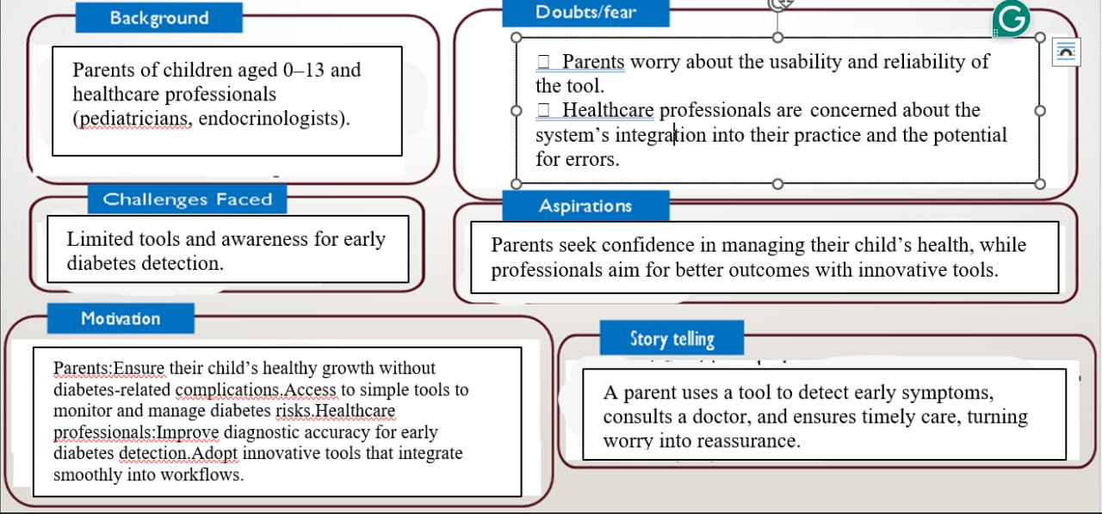

10. Look for Common Themes, Behaviors, Needs, and Pain Points among the Users

Common Themes:

Both parents and healthcare professionals prioritize early detection of diabetes to prevent complications. They also need user-friendly tools that are easy to use and understand. Anxiety is common, with parents worrying about their child’s health and professionals fearing missed diagnoses. Both groups value reliable data for making informed decisions.

Common Behaviors:

Parents and healthcare professionals actively seek information about diabetes and health management. Parents track symptoms, while healthcare professionals monitor patient data. Both take proactive actions when risks are identified and consult experts for confirmation, either through medical advice or diagnostic tools.

Common Needs:

Both groups need early detection tools for accurate diabetes diagnosis. User-friendly solutions that simplify tracking and monitoring health are essential. Accurate data is crucial for making informed decisions, and both seek peace of mind that their actions are based on reliable insights.

Common Pain Points:

Parents struggle with a lack of awareness regarding early diabetes signs, while healthcare professionals find tools too complex to use efficiently. Both groups experience anxiety about potential misdiagnoses or delayed intervention. There is also limited access to reliable health information and tools.

11. Define Needs and Insights of Your Users

User Needs:
- Functional Needs: Users require reliable, simple tools for early diabetes detection and ongoing monitoring to ensure their child's health is effectively managed.
- Emotional Needs: Parents seek peace of mind, knowing that they are taking proactive steps to manage their child’s health and prevent complications.
- Societal Needs: Affordable, accessible health solutions are essential for promoting overall well-being and preventing long-term health issues in children.

User Insights:
- Behavior: Parents are actively engaged in monitoring their child’s health but often lack clear guidance on identifying early signs of diabetes.
- Motivation: Both parents and healthcare professionals are motivated by the desire to prevent long-term health complications, emphasizing the importance of early detection.
- Pain Point: Parents feel anxious about missing signs of diabetes, while healthcare professionals face challenges with limited diagnostic tools and time constraints.
- Decision Drivers: Trustworthy, easy-to-use solutions that provide reassurance and accurate data are crucial for ensuring user engagement and adoption.

12. POV Statements

PoV Statements | Role-based or Situation-Based | Benefit, Way to Benefit,  Job TBD,  Need (more/less) | PoV Questions  (At least one per statement)
1. Parents need a way to monitor their child's health because they’re anxious about missing symptoms. | Situation | Early detection, easy monitoring tool, more clarity | How can we help parents track early diabetes signs easily?
2. Healthcare professionals need a reliable tool for early diagnosis because current methods are inefficient | Role-Based | Accurate diagnosis, efficient tool, more reliability | How can we help professionals diagnose diabetes more accurately?
3. Parents need a simple tracking solution because they lack knowledge of early diabetes symptoms. | Situation-Based | Peace of mind, user-friendly tool, more education | How can we make health tracking easier for parents?
4.Healthcare professionals need an integrated solution to detect early risks due to limited resources. | Role-Based | Early detection, automated risk assessment, more tools | How can we help professionals identify risks with fewer resources?
5. Parents need continuous health tracking to avoid missing symptoms between doctor visits. | Situation-Based | Ongoing monitoring, continuous tracking, more consistency | How can we enable continuous monitoring between doctor visits?

13. Develop POV/How Might We (HMW) Questions to Transform Insights/Needs into Opportunities for Design

How Might We: Based on the needs and insights you've identified, create open-ended questions starting with "How might we...?" These questions should aim to

• User Need: Users need reliable and simple tools for early diabetes detection and monitoring.
How might we create an easy-to-use tool that provides reliable early detection and ongoing monitoring of diabetes risks?
• Insight: Parents are actively engaged in monitoring their child’s health but lack clear guidance on identifying early signs of diabetes.
How might we provide clear, actionable guidance for parents to identify early signs of diabetes in their children?
• User Need: Parents seek peace of mind, knowing their child’s health is effectively managed.
How might we offer parents a solution that provides reassurance and confidence in managing their child’s health?
• Pain Point: Parents feel anxious about missing signs of diabetes, while healthcare professionals struggle with limited diagnostic tools and time constraints.
How might we reduce anxiety for parents and provide healthcare professionals with efficient, accurate diagnostic tools to detect diabetes early?
• Decision Driver: Trustworthy, easy-to-use solutions that provide reassurance and accurate data are crucial for user engagement.
How might we design a trustworthy, user-friendly platform that delivers accurate data and reassures both parents and healthcare professionals?

Write 3-5 "How Might We" questions based on your analysis of user needs and insights. These questions should challenge you to think of innovative solutions that can address user problems in meaningful ways.
This task encourages participants to think creatively about solving user problems, transforming challenges into opportunities for innovation.
User Need/Insight | "How Might We" Question
Parents need reliable and simple tools for early diabetes detection and monitoring. | How might we create an easy-to-use tool that provides reliable early detection and ongoing monitoring of diabetes risks?
Parents lack clear guidance on identifying early signs of diabetes in their children. | How might we provide clear, actionable guidance for parents to identify and respond to early signs of diabetes?
Healthcare professionals face time constraints and need efficient diagnostic tools. | How might we design a solution that seamlessly integrates into their workflow while improving diagnostic accuracy?
Parents experience anxiety about their child's health due to limited access to reliable information. | How might we offer parents a solution that provides accurate data and peace of mind?
Both parents and healthcare professionals value trustworthy solutions that simplify decision-making. | How might we develop a platform that simplifies decision-making with accurate, easily interpretable insights?

14. Crafting a Balanced and Actionable Design Challenge
Design Challenge:
How might we design a simple and accessible tool that helps parents and healthcare professionals detect and monitor early signs of diabetes in children, ensuring accurate results, reducing anxiety, and integrating easily into their daily routines?
This question focuses on actionable goals such as:
- Simplifying early diabetes detection.
- Providing accurate and reliable health insights.
- Reducing stress for users.
- Ensuring seamless usability and integration into existing workflow

15. Validating the Problem Statement with Stakeholders
Stakeholder/User Feedback:

Stakeholder/User | Role | Feedback on Problem Statement | Suggestions for Improvement
Dr. Anjali Sharma | Pediatrician | The problem resonates; early detection of diabetes in children is critical, but current methods are often missed. | Include a focus on preventative measures alongside diagnosis to address lifestyle interventions.
Dr. Ravi Mehta | Endocrinologist | The problem is significant, especially for high-risk patients, but there’s a lack of reliable tools. | Develop tools that integrate seamlessly with existing diagnostic workflows in clinics.
Mrs. Anita Verma | School Nurse | This is a valid concern, but schools often lack access to such tools. | Consider tools that are portable and can be used in schools or community health settings.
Mr. Ravi Kumar | Parent | Yes, this problem is highly relevant; as a parent, I’m concerned about missing early signs of diabetes in my child. | Emphasize the need for a simple and non-intrusive tool for monitoring children's health.
Ms. Neha Sharma | Data Analyst | The focus is good, but data collection methods might be challenging in diverse settings. | Suggest using wearable technology or mobile apps to collect data efficiently.
Mr. Sanjay Mishra | Technology Developer | The problem is clear, but ensuring real-time updates can be challenging with limited resources. | Prioritize lightweight and scalable technology solutions that support quick implementation.

16. Ideation

Ideation Process:
Idea Number | Proposed Solution | Key Features/Benefits | Challenges/Concerns
Idea 1 | Mobile Health App for Early Diabetes Detection | Easy to use, tracks symptoms, real-time data, accessible to parents | Requires user education, data privacy concerns, reliance on smartphones
Idea 2 | Wearable Sensor for Continuous Glucose Monitoring | Continuous, real-time monitoring, non-intrusive, data-driven insights | Expensive, requires maintenance, user comfort, battery life
Idea 3 | AI-based Diagnostic Tool for Pediatric Health Clinics | Fast and accurate diagnosis, integrates with existing systems, improves decision-making | High implementation costs, tech adoption by doctors, training needed
Idea 4 | Health Monitoring Wristband for Kids | Monitors vitals, sends alerts to parents, easy-to-wear for kids | May be uncomfortable for kids, durability issues, requires regular charging
Idea 5 | Interactive Educational Platform for Parents | Provides knowledge about early signs, prevention tips, easy access | Need for continuous content updates, might not engage all parents

Solution Concept Form

1. Problem Statement

The increasing prevalence of diabetes in children under 13 years poses significant health risks. Early detection is often delayed due to a lack of awareness, vague symptoms, and limited access to timely screening. This results in severe health complications that could have been prevented with earlier diagnosis and intervention. There is a critical need for an effective and accessible solution to enable early identification of diabetes, facilitating proactive care and improved health outcomes for children.

2. Target Audience
- Primary Users: Parents of children aged 0–13, especially those with a family history of diabetes or other risk factors.
- Secondary Users: Pediatric healthcare providers, including doctors, nurses, and clinics, to enhance early detection and patient care.
- Tertiary Stakeholders: Public health organizations and educators focusing on childhood health and wellness to promote awareness and early screening.

3. Solution Overview

A comprehensive, user-friendly digital platform integrating a mobile health app, wearable sensors, and AI-based diagnostic tools to detect diabetes early in children.
- Mobile App: Tracks symptoms, provides educational resources for parents, and delivers real-time alerts.
- Wearable Sensors: Monitors glucose levels and vital signs continuously.
- AI Diagnostic Tool: Analyzes data to assist clinicians in timely decision-making, reducing risks of complications.

4. Key Features
Feature | Description
Real-time Monitoring | Continuous tracking of glucose levels and vital signs via wearable sensors.
AI-based Diagnostics | AI-powered analysis of collected data for accurate early diagnosis and decision support.
Parent & Doctor Alerts | Automated alerts to parents and healthcare providers if potential signs of diabetes are detected.

5. Benefits
Benefit | Description
Early Detection & Prevention | Enables early identification of diabetes, allowing timely intervention to prevent complications.
Improved Health Monitoring | Continuous monitoring ensures comprehensive tracking, enhancing health management.
User-Friendly & Accessible | Easy-to-use app and wearable, ensuring broad accessibility for parents and healthcare providers.

6. Unique Value Proposition (UVP)

A seamless, integrated approach to early diabetes detection in children, combining real-time glucose monitoring, AI-powered diagnostics, and personalized alerts. This solution stands out for its accessibility and actionable insights, enabling even non-experts to track and manage children's health effectively.

7. Key Metrics
Metric | Measurement
Early Diagnosis Rate | Percentage of children diagnosed with diabetes at an early stage compared to prior rates.
User Engagement | Number of active users (parents and healthcare providers) regularly using the app and wearable.

8. Feasibility Assessment

This solution is feasible using current technologies like wearable sensors, AI diagnostic tools, and mobile apps.
- Challenges:
  - Integration with existing healthcare systems.
  - Ensuring adoption by non-tech-savvy parents.
- Development Timeline: 12–18 months.
- Resources Needed: Funding for development, partnerships with healthcare providers, and ongoing product updates and user training.

9. Next Steps
- Research & Collaboration: Partner with pediatricians, healthcare organizations, and diabetes experts to validate the solution and refine the diagnostic algorithm.
- Prototype Development: Build a prototype for the wearable sensor and mobile app with real-time data integration.
- User Testing: Conduct usability testing with parents and healthcare providers to refine the interface and features.
- Regulatory Approval: Obtain certifications from regulatory bodies like the FDA or CE for health-related devices.
- Pilot Launch: Roll out a pilot program in select regions or clinics to assess effectiveness and collect optimization data.
- Market Strategy: Develop a marketing plan to raise awareness among parents, schools, and healthcare providers.

